ECEN 100 Project: Controlling System with Relays

Introduction
The ESP32S and microcontrollers like it are very good and managing and controlling low voltages and low currents. But what if you want to control much larger voltages and currents? One way to do this is with switching transistors which can handle moderate voltages and currents. But what if you want to control the lights and appliances in your home. This is normally associated with 120 volts and currents as high as 10 amps. To make this happen you need to use an electronic relay. These come in a number of packages and configuration, but here is what a standard relay might look like.
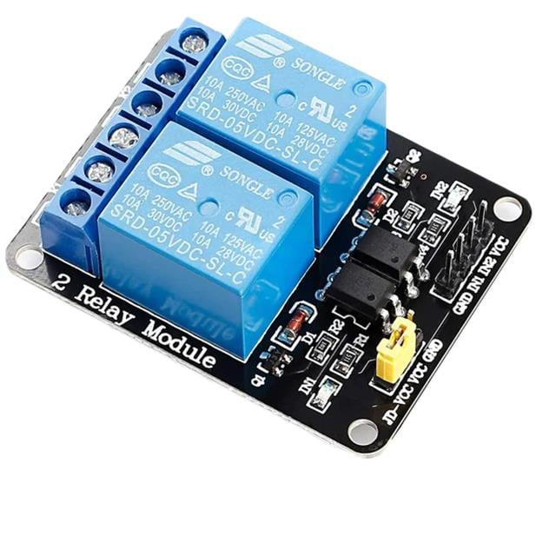
This package includes the hardware to electronically control the relay. The basic component of the relay is the coil, housed in the blue component on the board. The base relay looks like this inside:
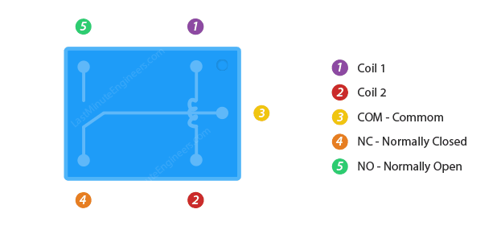
When no voltage is applied to the coil then the COM (Common) connection is connected to the NO (Normally Open) connection. When the voltage is applied then the COM connections is connected to the NC (Normally Closed) connection.

Hardware Needed
The 2 channel relay board from your kit.

Controlling the Relay
The connections on the relay board look like this:

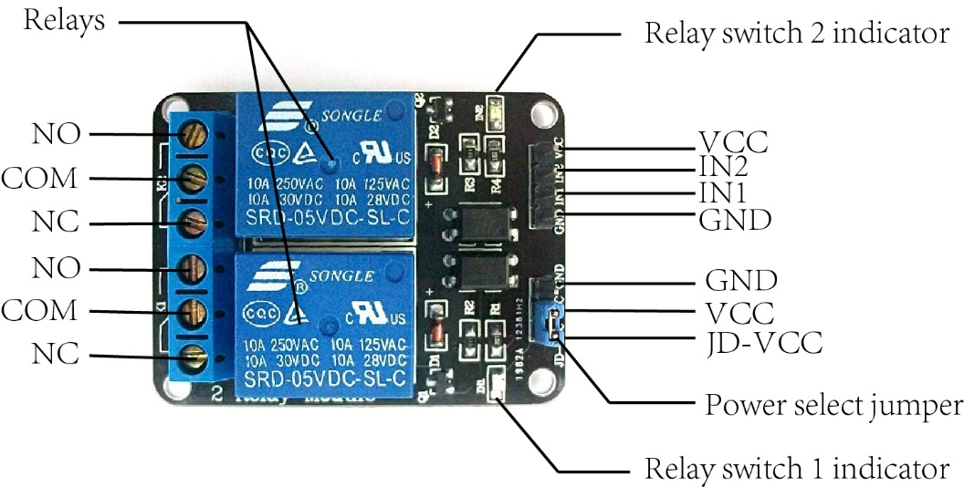

Let’s look in details at the connections. First, the high voltage/current connections.
COM – This is the common connection. This will come from the power source.
NO – Normally Open. When the input is set to LOW the COM connection will be connected to this terminal.
NC – Normally Closed. When the Input is set to HIGH then the COM connection will be connected to this terminal.
Now the control/power section. Here are the connections.
VCC – Voltage from the controlling device. This will energize the coil. This can be either 3.3 or 5 Volts for the device in your kit.
GND – GND from the controlling device.
IN1/IN2 – The control voltage for the two different relays.
There is another set of pins on the relay that need explaining.
The JD-VCC pin on a 2-channel relay module provides power directly to the electromagnetic relay coils (usually 5V or 12V). It allows you to separate the power supply for the power-hungry coils from the control logic (VCC pin), typically to prevent electrical noise or overcurrent from damaging microcontrollers like Arduino.

Key Details on Using JD-VCC:
- With Jumper (Default): The jumper connects JD-VCC to VCC. Both the relay coils and the optocoupler logic are powered by the same 5V supply.
- Without Jumper (Isolated): Remove the jumper to power the coils with an external supply (e.g., a 12V source if using 12V relays) connected to JD-VCC and GND, while the microcontroller powers the logic via the VCC pin.
- Safety & Power: Using a separate supply for JD-VCC provides better electrical isolation, protecting the microcontroller from the high-voltage load side.
If you are just toggling small loads, leaving the jumper in place and using the Arduino's 5V is fine. If you hear buzzing or notice erratic behavior, move to a separate power supply using the JD-VCC pin.

An Example Hardware Connection
If you were going to use the relay to control a light bulb powered by the power from a power receptacle then it could look like this:

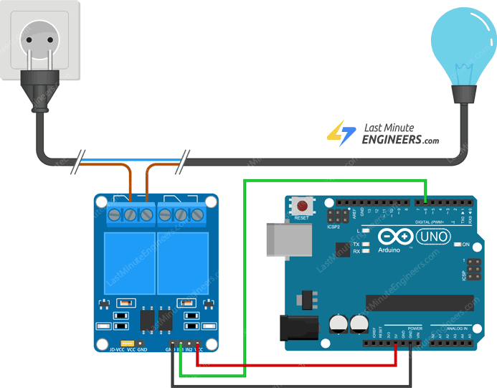
ESP32S3 Dev Board
Green – Pin 13
Red – 5 Volts
Black - GND
If you are going to build a circuit like this make sure you unplug the power connection to the receptacle until all the other connections have been made. Making contact with power line voltage and current can be deadly.
There is a better connection approach if you are going to connect to the power line. This connection uses the isolation available in the relay to avoid between the power line and the lower voltages from the control circuit.
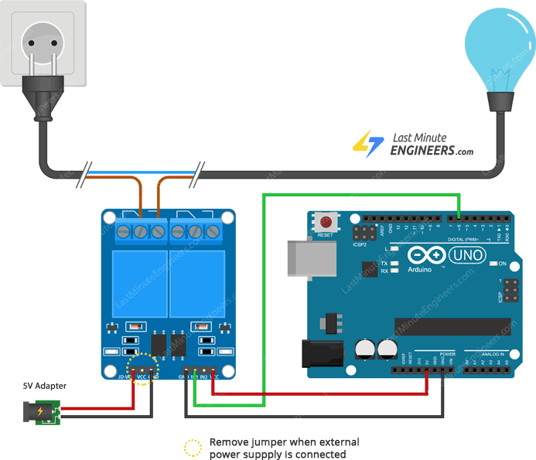
Development Board
Green – Pin 13
Red – 3.3 Volts
Black - GND
There are other applications that don’t use the AC power from the power system, but use DC voltages from the battery. Here is an example of this circuit.

An Arduino Sketch to Control the Relay
Here is a basic sketch for relay control.
#define RelayPin 13

void setup() {
// Set RelayPin as an output pin
pinMode(RelayPin, OUTPUT);
}

void loop() {
// Let's turn on the relay...
digitalWrite(RelayPin, LOW);
delay(3000);

// Let's turn off the relay...
digitalWrite(RelayPin, HIGH);
delay(3000);
}

Controlling the Relay is as simple as controlling the pin. Whether you want the circuit to be active when the control signal is low or whether you want the circuit to be active when the circuit is high will determine which connectors you use on the relay. NC (Normally Closed) will be active when the control signal is LOW, and NO (Normally Open) will be active when the signal circuit is HIGH.
Additional Possibilities for this Project
- Add the web page capability to your sketch to control the system remotely.
- You can use a remote Arduino control app with your phone to control the system truly remotely.

